**Kamala College, Kolhapur**



A

PROJECT REPORT

ON

“Expense Analysis”

A PROJECT REPORT SUBMITED

TO

SHIVAJI UNIVERSITY, KOLHAPUR

IN THE PARTIAL FULFILMENT OF REQUERMENT FOR

THE DEGREE

BACHELOR OF COMPUTER APPLICATION

Submitted By

Miss. Arpana Anandrao Patil.

UNDER THE GUIDANCE OF

Miss. Rutuja Bhedate.

Through

TARARANI VIDYAPEETH’S

KAMALA COLLEGE, KOLHAPUR

2023-2024

**Kamala College, Kolhapur**



**CERTIFICATE**

This is to certify that the Project entitled **“Food Services”.** Which is being submitted here with for the award of the degree of Bachelor of Computer Application of Shivaji University through Kamala College, Kolhapur is the result of the original work completed Under my Supervision and guidance.

To the best of knowledge and belief, this work has not been previously submitted by the award of the degree or Diploma of this university or any other university or institute.

**Place: Kolhapur**

**Date:**

**Miss. Rutuja Bhedate. Examiner Miss. Rohini Lokare**

**(Project Guide) (H.O.D)**

**Kamala College, Kolhapur**



**DECLARATION**

We, undersigned, hereby declare that the project entitled **“Grocery Shop”** being submitted for the award of the degree of Bachelor of Computer Application by use to Kamala College, Kolhapur is the result of an independent research work carried out under the guidance of **Prof. Rutuja Bhedate.** This is my original work and conclusion drawn there in are based on the information collected by us.

Further we declare that, this project has not been submitted to this or any University or Institution for the award of any degree.

**Place: Kolhapur**

**Date:**

Miss. Arpana Anandrao Patil.

**Kamala College, Kolhapur**



**ACKNOWLEDGMENT**

This project entitled **“Grocery Shop”,** which is submitted and we take this opportunity to express our deep sense of gratitude and grateful thanks to our guide **Prof. Rutuja Bhedate**

for her guidance right from initial stage of project in systematic manner.

We are thankful to all other teachers of computer department and all staff of computer lab for their co-operation during the compilation of this project.

We are also thankful to those who are directly or indirectly related to project work because without their co-operation and guidance it would have become externally difficult to complete this task in time.

**INDEX**

|  |  |  |
| --- | --- | --- |
| **SR NO.** | **PARTICULARS** | **PAGE NO.** |
| 01 | Introduction to Project | 6-8 |
| 02 | Proposed System | 9-15 |
| 03 | System Analysis | 16-23 |
| 04 | System Design | 24-32 |
| 05 | Implementation | 33-37 |
| 06 | Reports | 38-39 |
| 07 | Conclusion and Suggestions | 40 |
|  | Annexure | 41-44 |
|  | Student Guide Meet Record | 45 |
|  | Reference | 46 |

**INTRODUCTION**

Online Shopping is a way of buying food and other household necessities using a web-based shopping service. There are two basic methods that people can use to purchase these items online. One is to order them from a local grocery store that participates in shopping.

A customer can then arrange for a home delivery directly from the store, or he can pick up his order at the store once an employee has assembled it. Another common practice is to order groceries from a large company, such as Amazon or Net grocery, that will ship the items to one’s home.

Online markets have been a thing has come to stay with the society if today since most financial transactions can be attained online. Internet access has vastly grown across in the world today and has given rise to interconnectivity even to the remotest areas in the world. This generally means it is possible to be at any location and reach any other location in the world without stepping a foot out of your premises. This takes multi-tasking to another level since you can be in a meeting and visit a market located several kilometers away at the same time. This has made businesses to grow without spending as much as they would have if they had to build another branch if their business in another location. Groceries are different from many other products, such as music and books, that are commonly purchased online. Many grocery products are perishable and therefore time-sensitive in terms of their delivery needs.

**EXISTING SYSTEM**

The current system for shopping is to visit the shop manually and from the available grocery item choose the item user want and buying the item by payment of the price of the item. Grocery stores also offer non-perishable foods that are packaged in bottles, boxes, and cans; some also have bakeries, butchers, delis , and fresh produce. Large grocery stores that stock significant amounts. Some large super markets also include a pharmacy, and user services, redemption, and electronic sections. Some grocery stores (especially large ones) from the centerpiece of a larger complex tat includes other facilities, such as gas stations, which will often operate under the store’s name. Some groceries specialize in the foods of a certain nationality or culture. These stores are known as ethnic markets and may also serve as gathering places for immigrants. In many cases, the wide range of grocery items carried by large super markets has reduced the need for such specially stores the variety and availability of food is no longer restricted by the diversity of locally grown food or the limitations of the local growing seasons.

**DRAWBACKS OF EXISTING SYSTEM**

* User must go to shop and select grocery items.
* It is difficult to identify the required grocery item.
* Description of the grocery item limited.
* It is a time- consuming process.
* Not in reach of distant users.
* It is less user-friendly.

**NEED AND SCOPE OF COMPUTER SYSTEM**

1. The system allows only authorized users to access the date.
2. System is use of friendly and gives quick results.
3. Data is stored in a systematic way in a database.
4. Reports are accurately generated on timely basis.
5. Data can be retrieved efficiently as and when required by the user.
6. Reports are accurately generated by selecting the appropriate identification code.
7. Data stored in computer is easily accessible than current manual system.

**PROPOSED SYSTEM**

In the proposed system user need not go to the shop for buying the grocery items. He can order the grocery item the wishes to buy through the application in his website. The shop owner will be admin of the system. Shop owner can appoint moderators who will help owner in managing the users and grocery item orders. The system also recommends a home delivery system for the purchased grocery items.

**ADVANTAGES OF PROPOSED SYSTEM**

* Save on transportation costs. Back when I was working away from home, I simply scheduled my time to saving by the grocery store on the way home from work.
* Save time. A 28-mile round trip, plus whatever time it takes to shop can easily burn up an hour or more of my day.
* Stay organized.

**REQUIREMENT ENGINEERING**

Requirement Engineering (RE) refers to the process of defining, documenting, and maintain requirements in the engineering design process. Requirements engineering provides the appropriate mechanism to understand:

* What the customer desire.
* Analysing the need.
* Accessing feasibility.
* Negotiating a reasonable solution.
* Specifying the solution clearly.
* Validating the specification.
* Managing the requirements as they are transformed into a working system.
* **Feasibility Study-**

The objective behind the feasibility study is to create the reason for developing the software that is acceptable to users, flexible to change and comfortable to establish standards. The feasibility study is mainly on the necessity if the proposed system in the organization.

**1] Technical Feasibility-**

The assessment of this feasibility must be base on outline design of system requirement in this term input, output and program procedure are concern. Technical feasibility also evaluates the current technologies, which are needed to accomplish Customer requirements , within the time and budget.

**2] Operational Feasibility-**

The assessment of this feasibility looks after how it satisfies the requirement and analysis of system development by checking system work cyclically such as purchase. It also prefers to the measure of solving problem with the help of new proposed system.

**3] Economical Feasibility-**

The assessment of this feasibility is the system which is developing as part of project work then there is no mutual for proposed system also all resources bare already available. It gives a conduct of system is economically possible for development.

**Requirement Gathering**

Requirement gathering, also known as the discovery phases, is a process that involves researching, identifying, and documenting a project’s requirements from the beginning to the end.

Usually, this process takes place during the project initiation phase, like a project brief or initial kick-off meeting, but it continues to handle the requirements throughout the entire project timeline.

Requirement gathering discusses the duration of project schedule, members to be involved in the project , the various risks a project may face, and many other crucial project elements.

This process is primarily used by project managers to prioritize and create a list of goals, and then streamline operations to finish their projects within a short time period. It helps increase profits and returns on investment for the company.

The various techniques used by a project manager for requirements gathering include interviews, questionnaries, user observation, stories, prototyping, role-playing, and scenarios and use cases.

Now, that you know what requirements gathering is, let’s try and understand why it is an important process for your project ventures.

**Software Engineering**

Software Engineering Tutorial delivers basic and advanced concept of software Engineering. Software Engineering Tutorial is designed to help beginners and professionals both.

Software Engineering provides a standard procedure to design and develop a software.

Our software Engineering Tutorial contains all the topics of Software Engineering like Software Engineering Models, Software Development Life Cycle Requirement Engineering, Software Design tools, Software Design Strategies, Software Design levels, Software Project Management, Software Management activities, Software Management Tools, Software Testing Levels, Software Testing approaches, Quality Assurance Vs. Quality control, Manual Testing, Software Maintenance, Software Re-engineering and Software Development Tool

Such as CASE Tool.

**Huge Programming:** It is simpler to manufacture a wall then to a house or building, similarly, as the measure of programming become extensive engineering has to step to give it a scientific process.

**Adaptability:** If the software procedure were not based on scientific and engineering ideas, it would be simpler to re-create new software than to scale an existing one.

**Cost:** As the hardware industry has demonstrated its skills and huge manufacturing has let down the cost of programming remains high if the proper process is not adapted.

**Dynamic Nature:** The continually growing and adapting nature of programming hugely depends upon the environment in which the client works. If the quality of the software is continually changing, new upgrades need to be done in the existing one.

**Quality Management:** Better procedure of software development provides a better and quality software product.

**QUESTIONNIRES**

* From the above five techniques, We have used the Questionnaires as a Requirement Gathering method for our software development.
* These are the following questions that we have prepared to ask the customers, to gather the requirements.

Why do you want to work in a grocery store/retail supermarket ?

Do you have any previous working experience from retail ?

How do you imagine a typical day in this job ?

This is repetitive job. What will motivate you to work hard day after day in our grocery store(supermarket) ?

What are your weaknesses if we talk about a job on a grocery store clerk ?

What is your availability ?

How important is teamwork for you ?

How would you describe an ideal boss ?

How would you define a great customer services ?

What are your salary expectations ?

**SOFTWARE REQUIRMNETS**

A software requirements specifications is a “structured collection of the requirements (functions, performance, design constraints, and attributes) of the software and its external interfaces”.

The software requirements specifications represents the results of the requirements analysis and describes the requirements of the software under development.

Through, it is created as a document that describes requirements for a software products, program or set of programs.

* **Some of the ways where, in different software this methods are used-**

**Analyses the Data-**

Analyses all the business data using analytic dashboard, analyses all sales, orders, stock, etc.

**Manage Accounting-**

Manage customers and Vendor’s accounts, tracks all the expenses and income.

**Advanced Notification-**

Enable the SMS and Email notification, brings more customers using discount and loyalties.

**Generate Reports-**

Customize and generate the reports as per requirements.

* **Key benefits of Grocery Managements System Software-**

Enjoy a convenient shopping experience.

Reduce temptation for impulse buying unhealthy items.

Stay on budget by searching for lowest-price items, using electronic coupons and knowing the running total before checkout.

Plan meals ahead of time and avoid buying items that are already on hand.

Know what products are in stock and choose substitutions when needed.

Add items to your virtual cart throughout the week, as a modern-day shopping list.

Choose how to receive the items, such as through free store pickup or an at-home delivery service

**3. SYSTEM ANALYSIS**

* **DATA FLOW DIAGRAM-**
* **0th Level DFD (Context Level Diagram)**

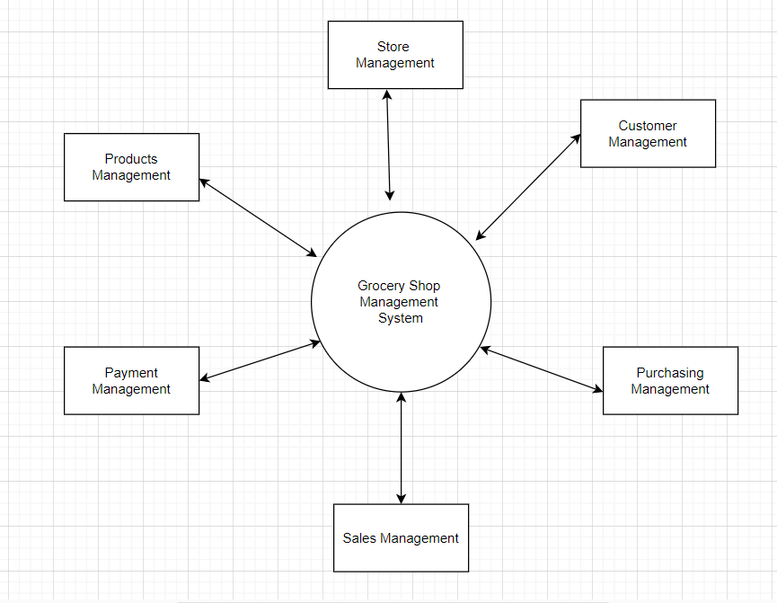

* **1st Level DFD-**

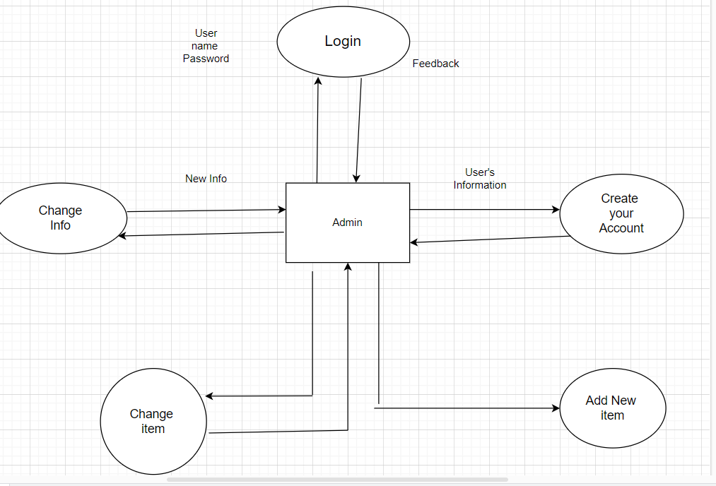

**2nd Level DFD-**

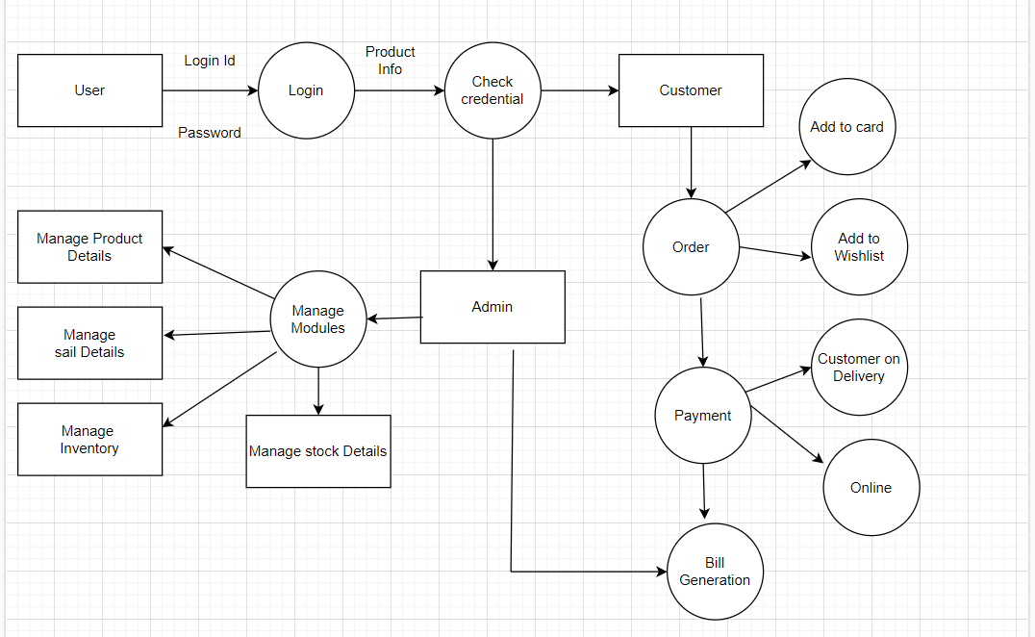

* **ER-Diagram-**

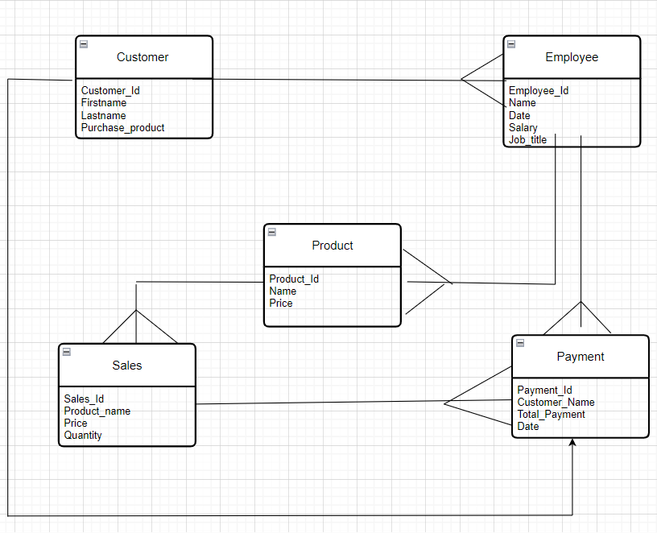

* **Component Diagram-**

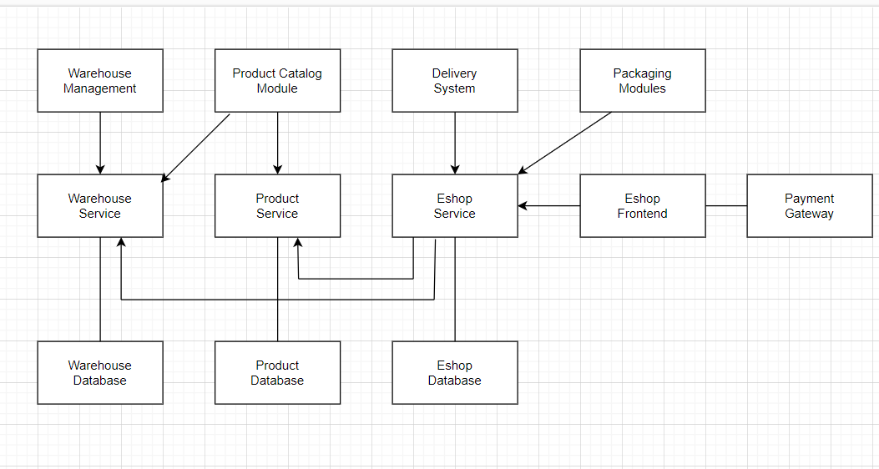

* **Activity Diagram-**

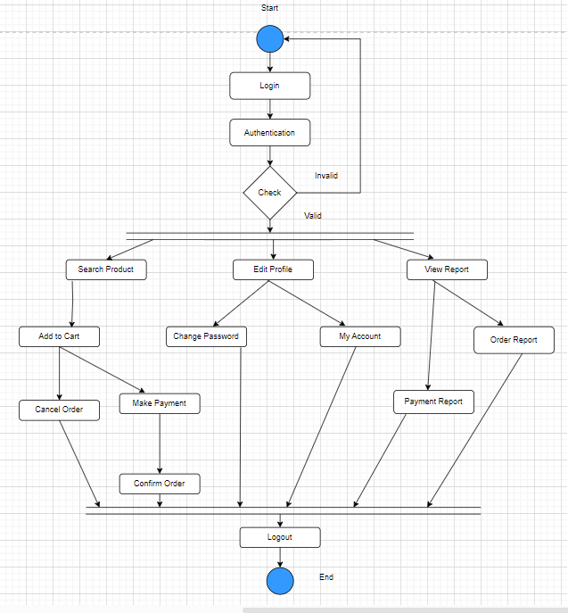

* **Use Case Diagram-**

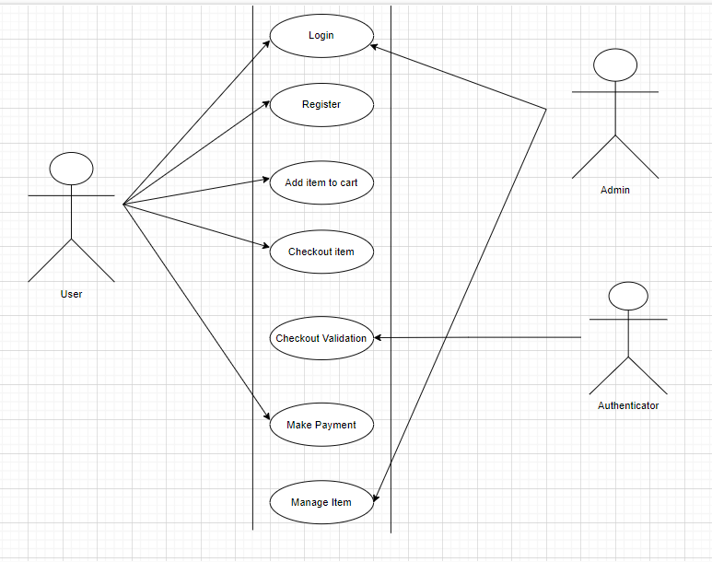

* **Sequence Diagram-**

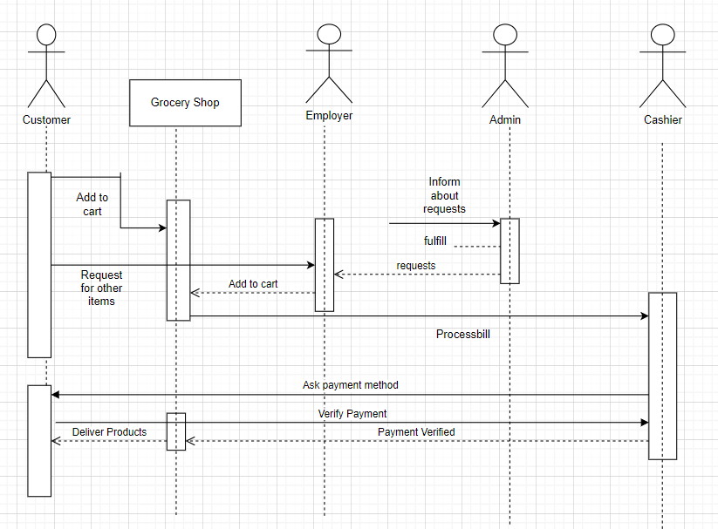

**SYSTEM DESIGN**

**Output-**

**Home page –**

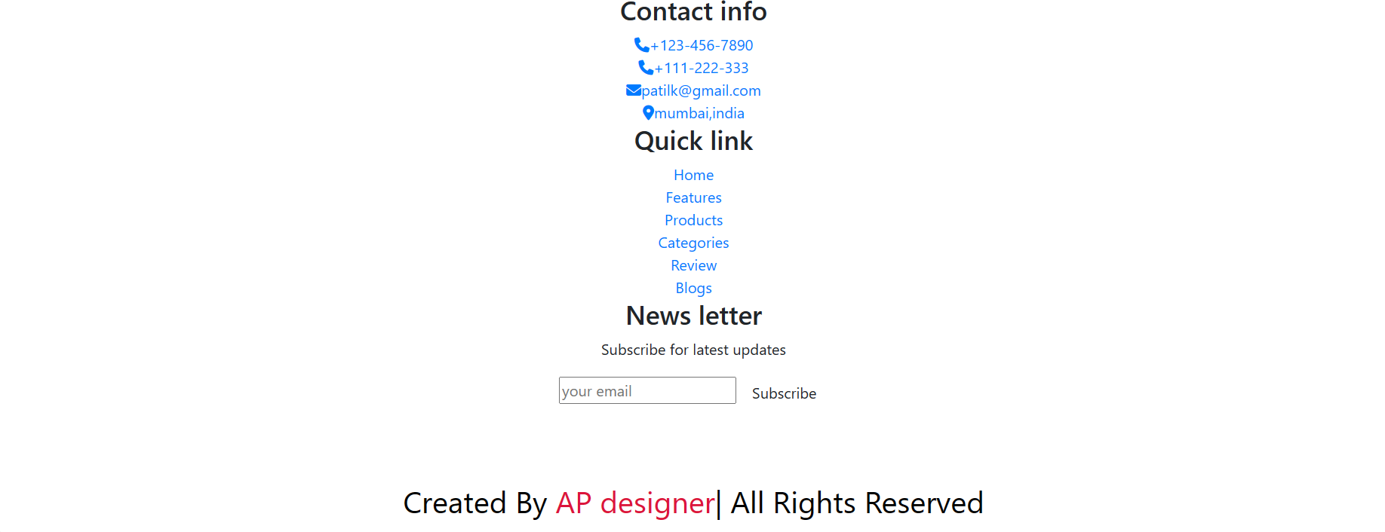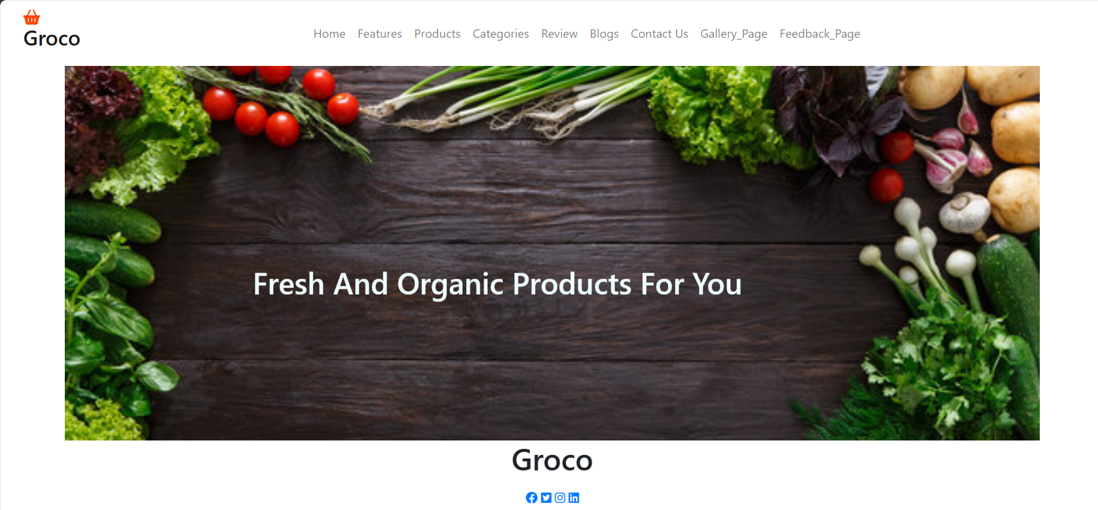

**Features Page-**

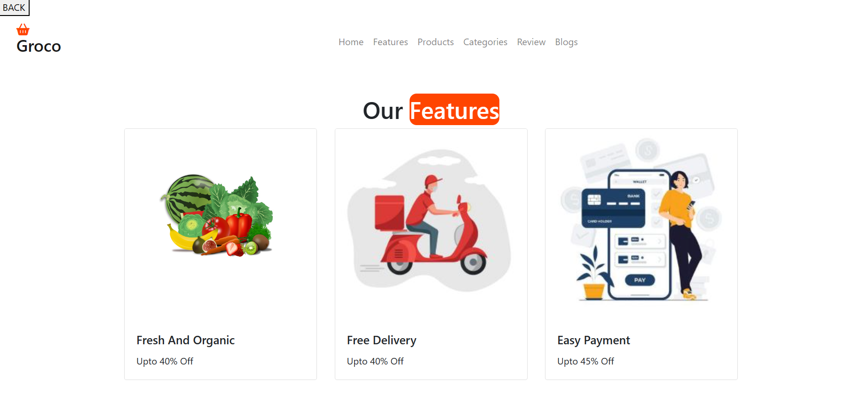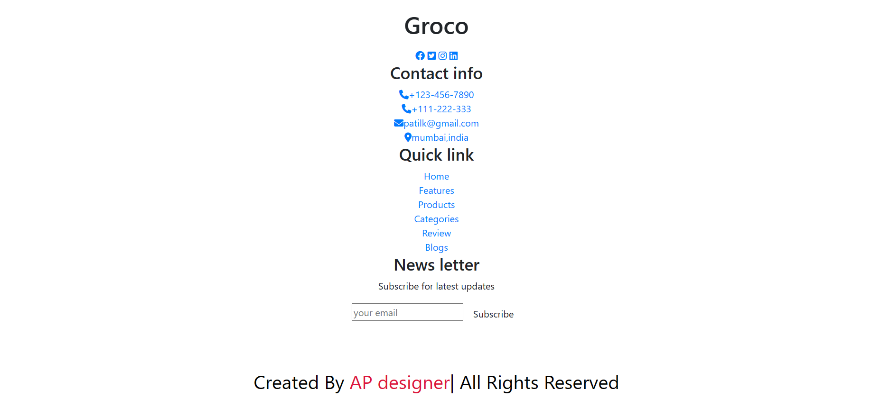

**Products Page-**

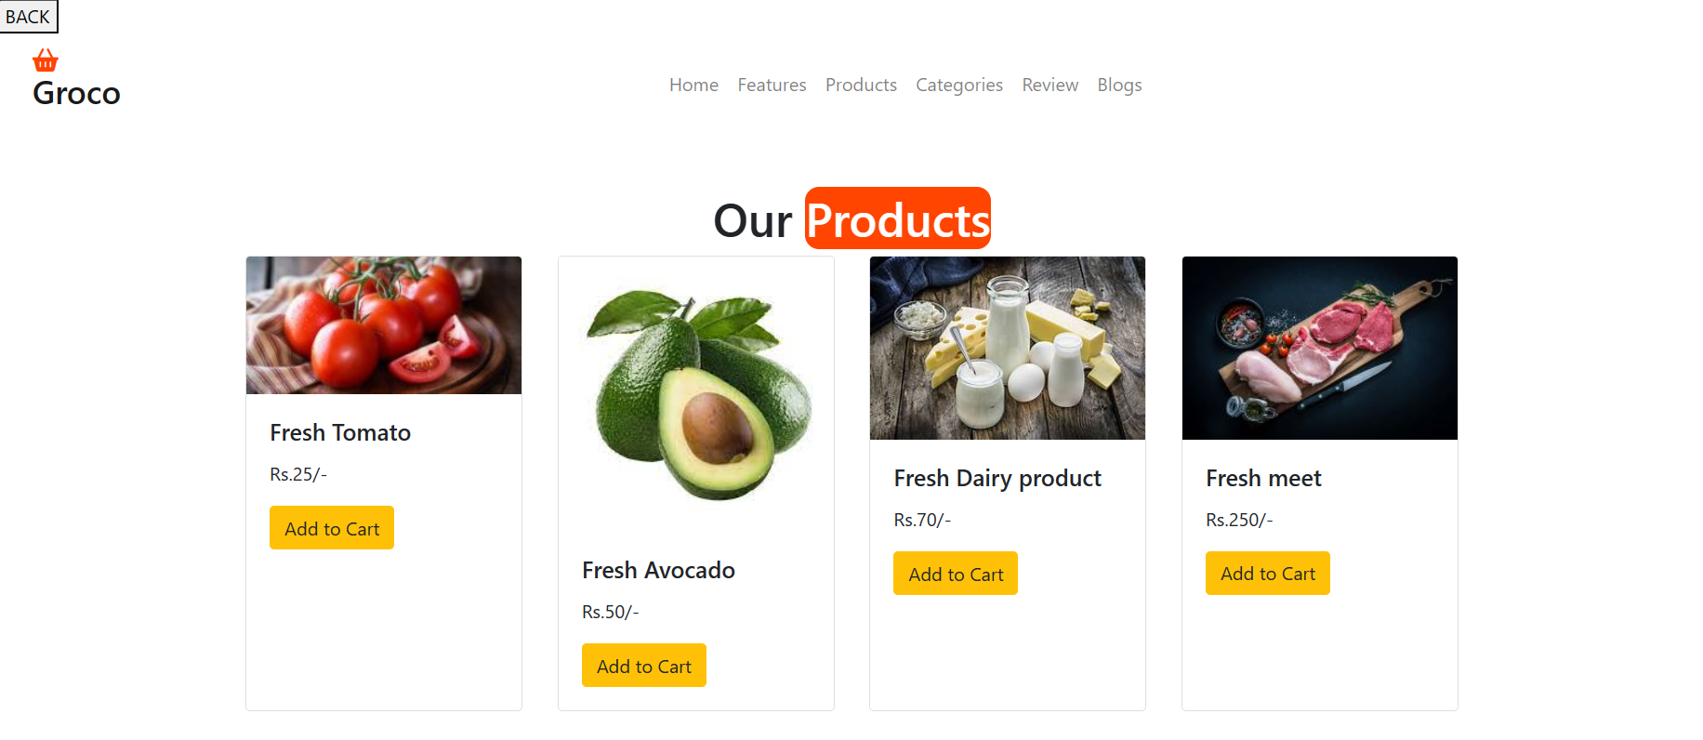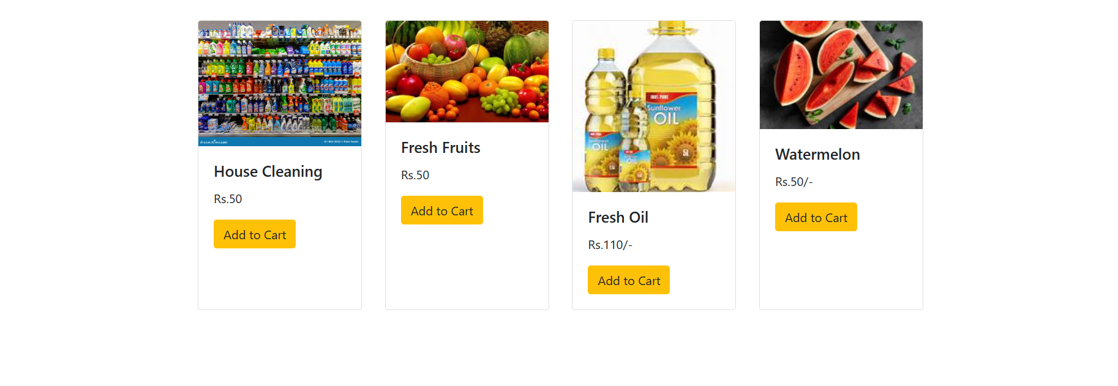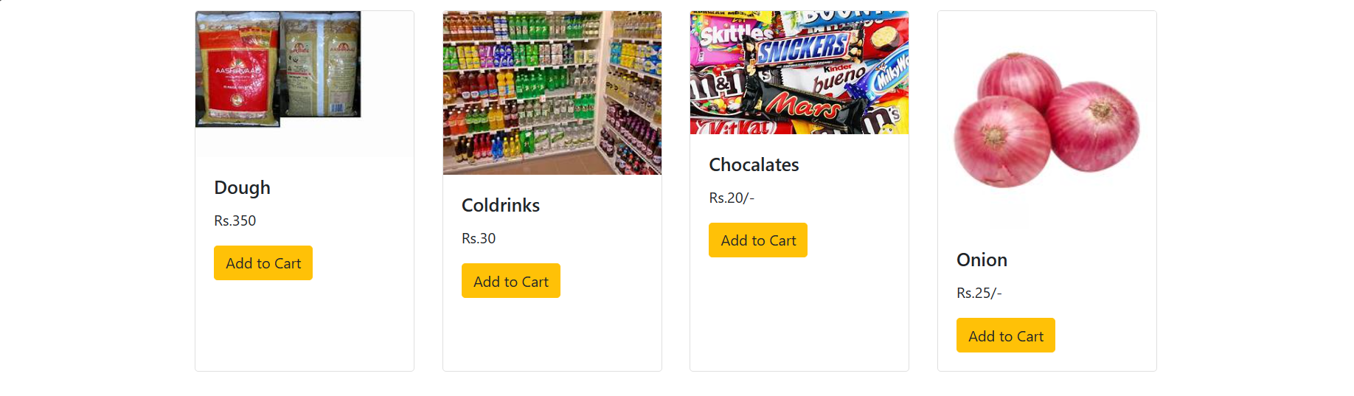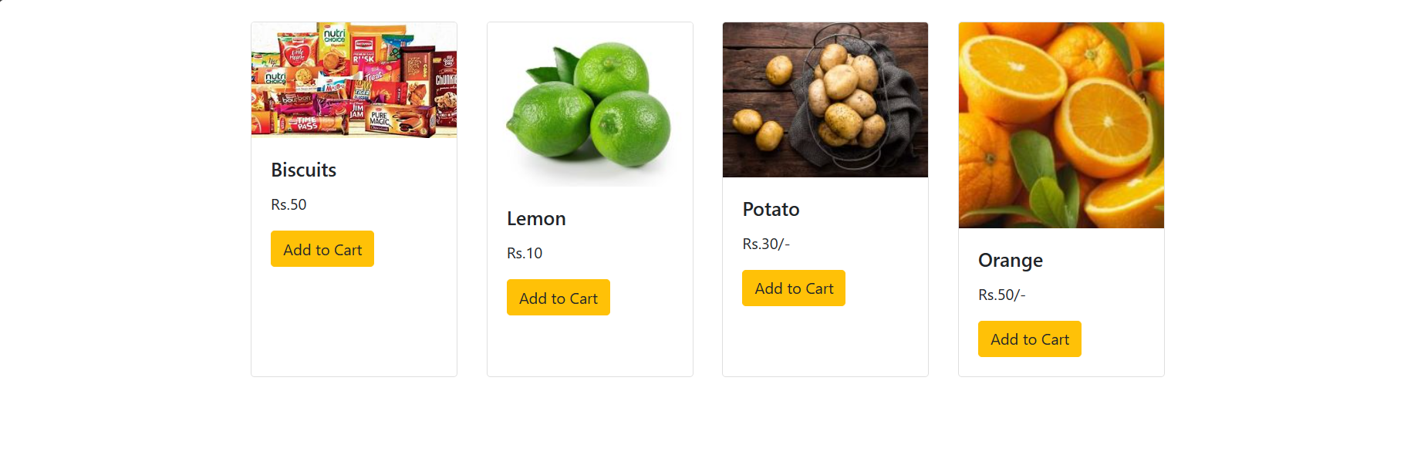

**Add to cart form-**

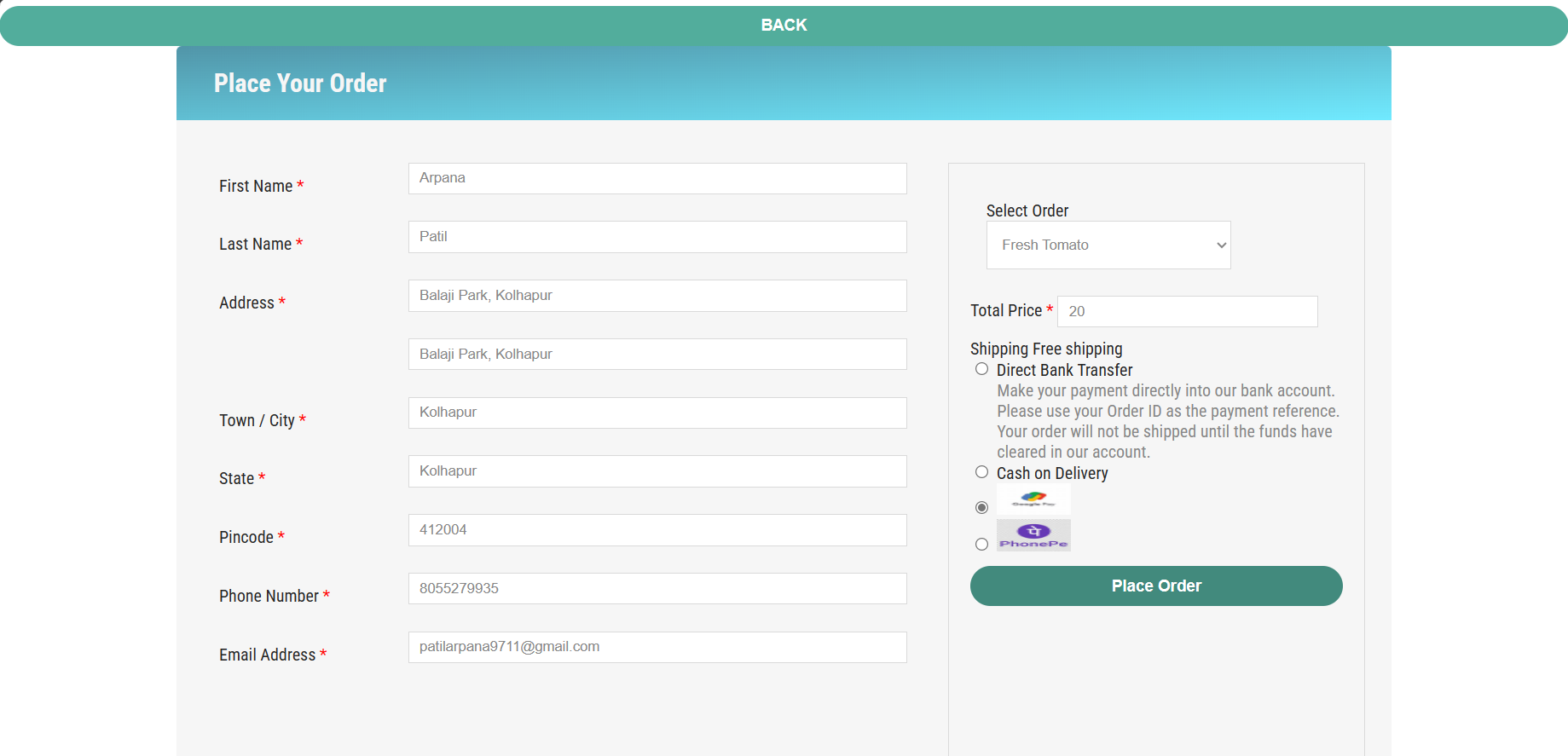



**Categories Page-**

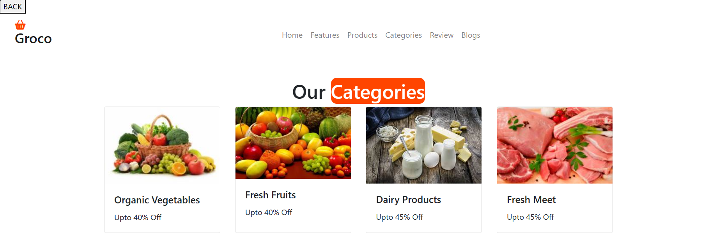

**Review Page-**

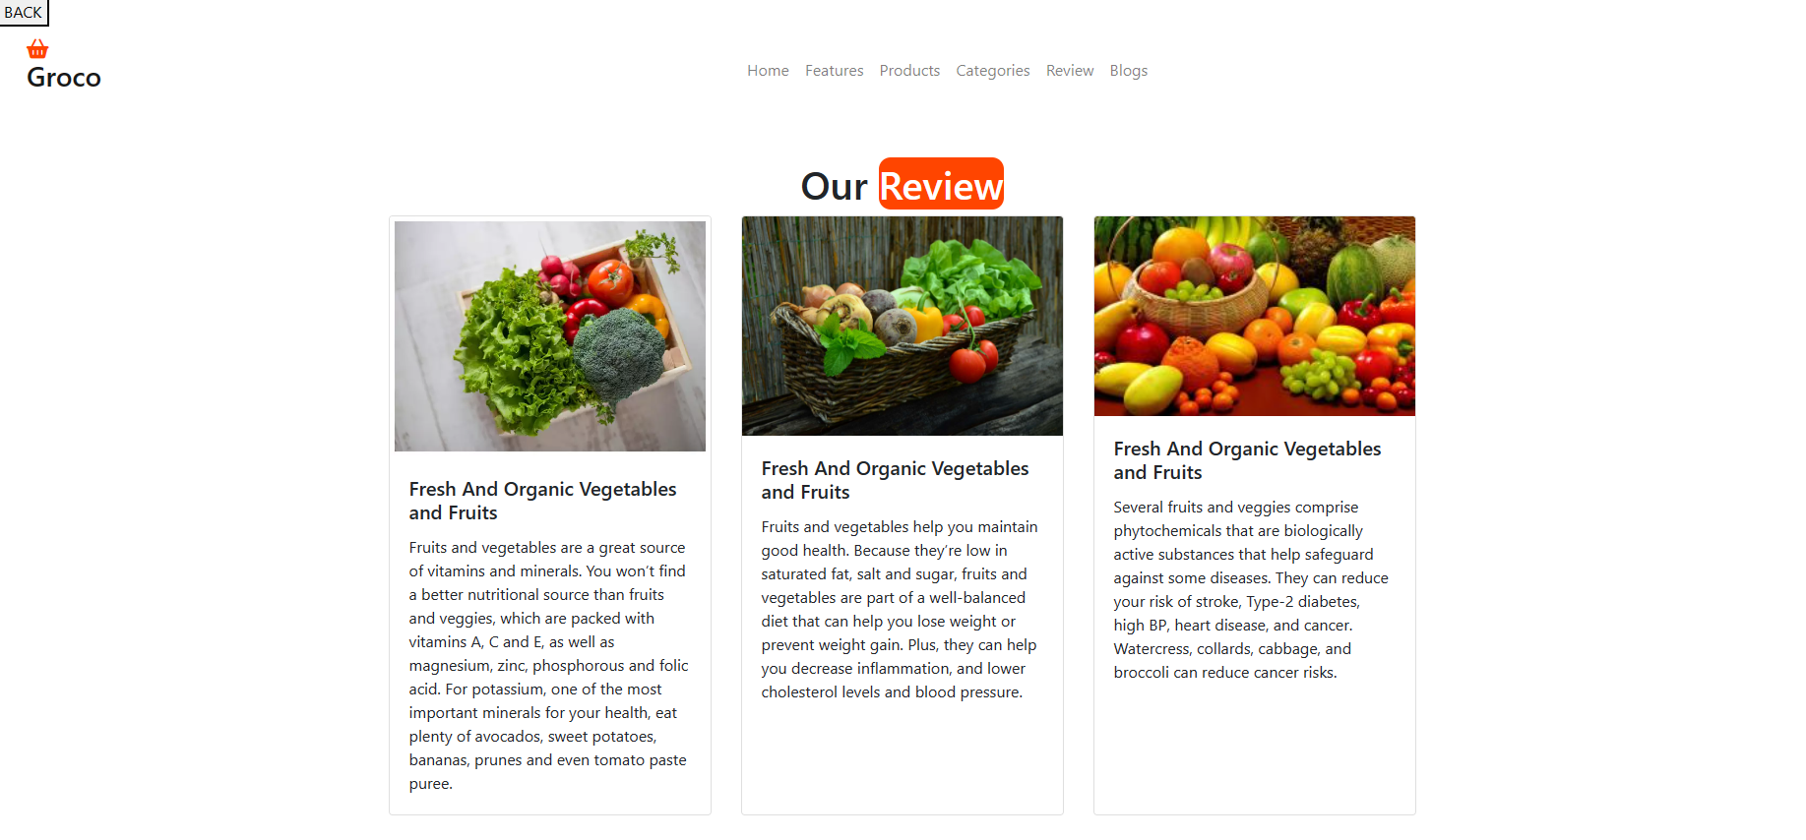

**Blogs Page-**

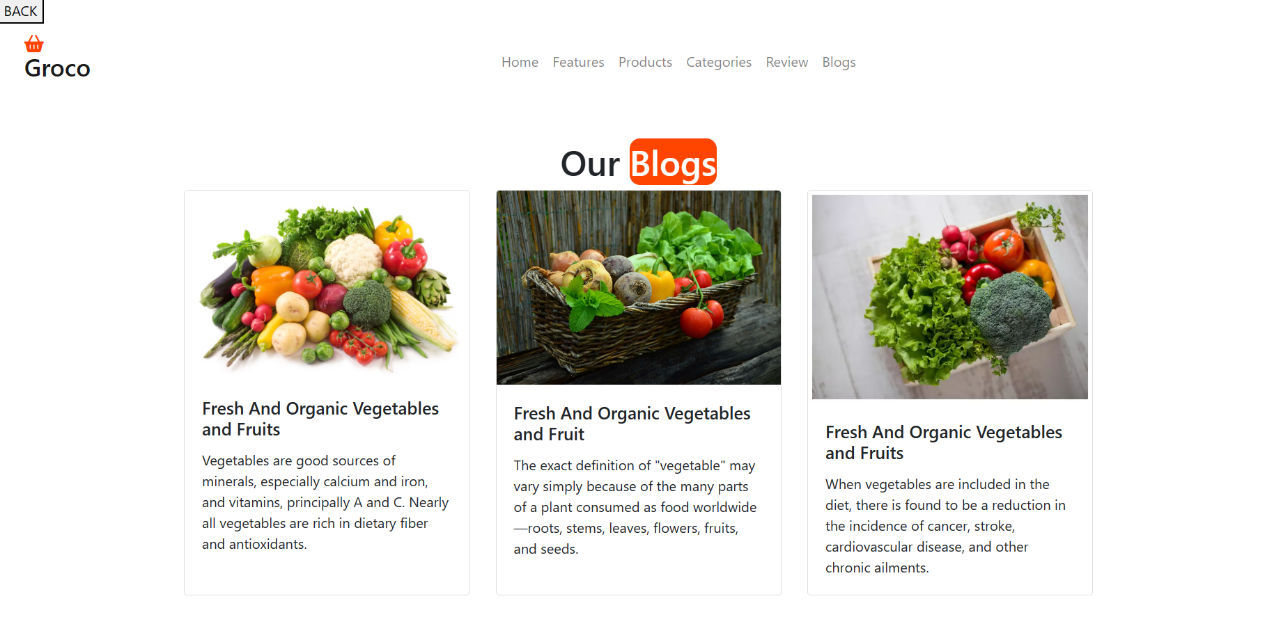

**Contact us Page-**

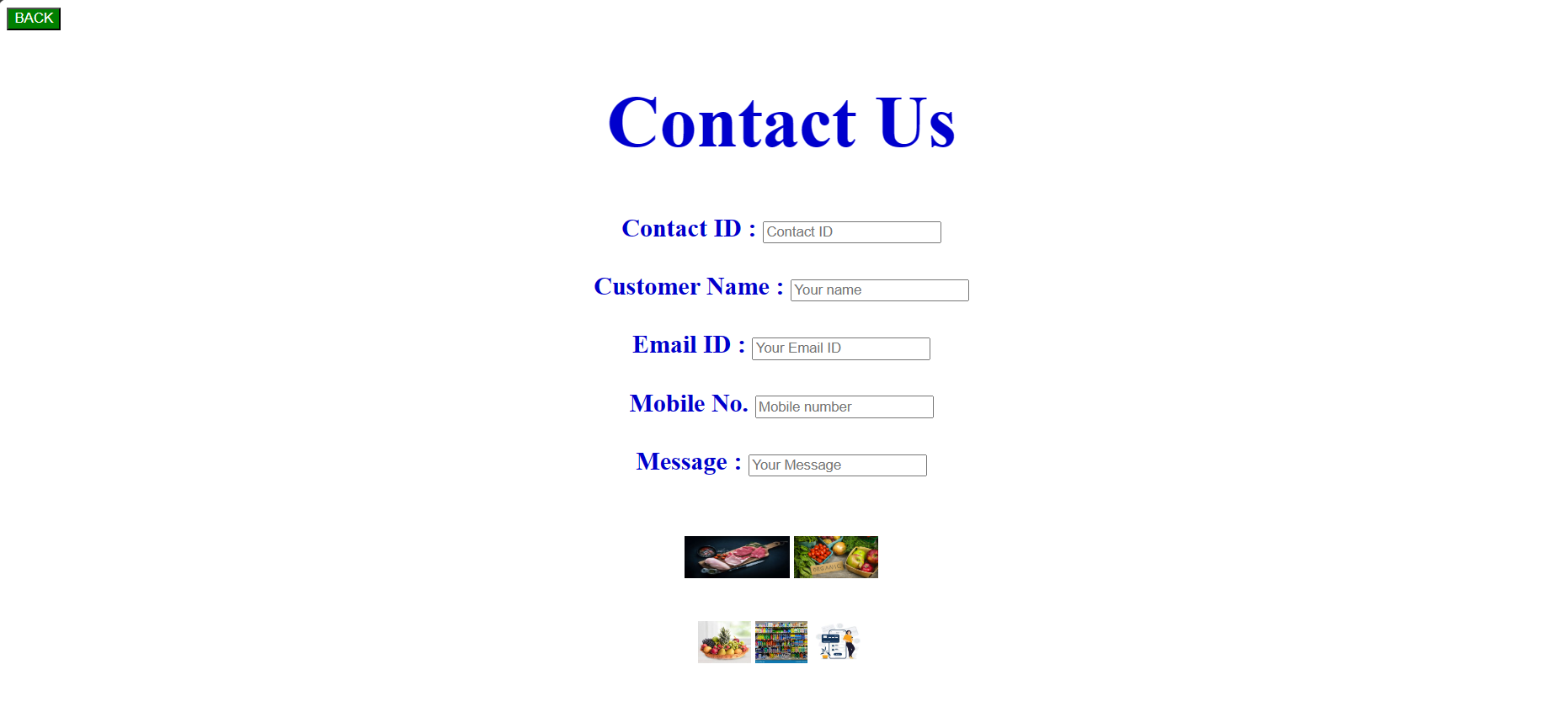

**Gallery Page-**

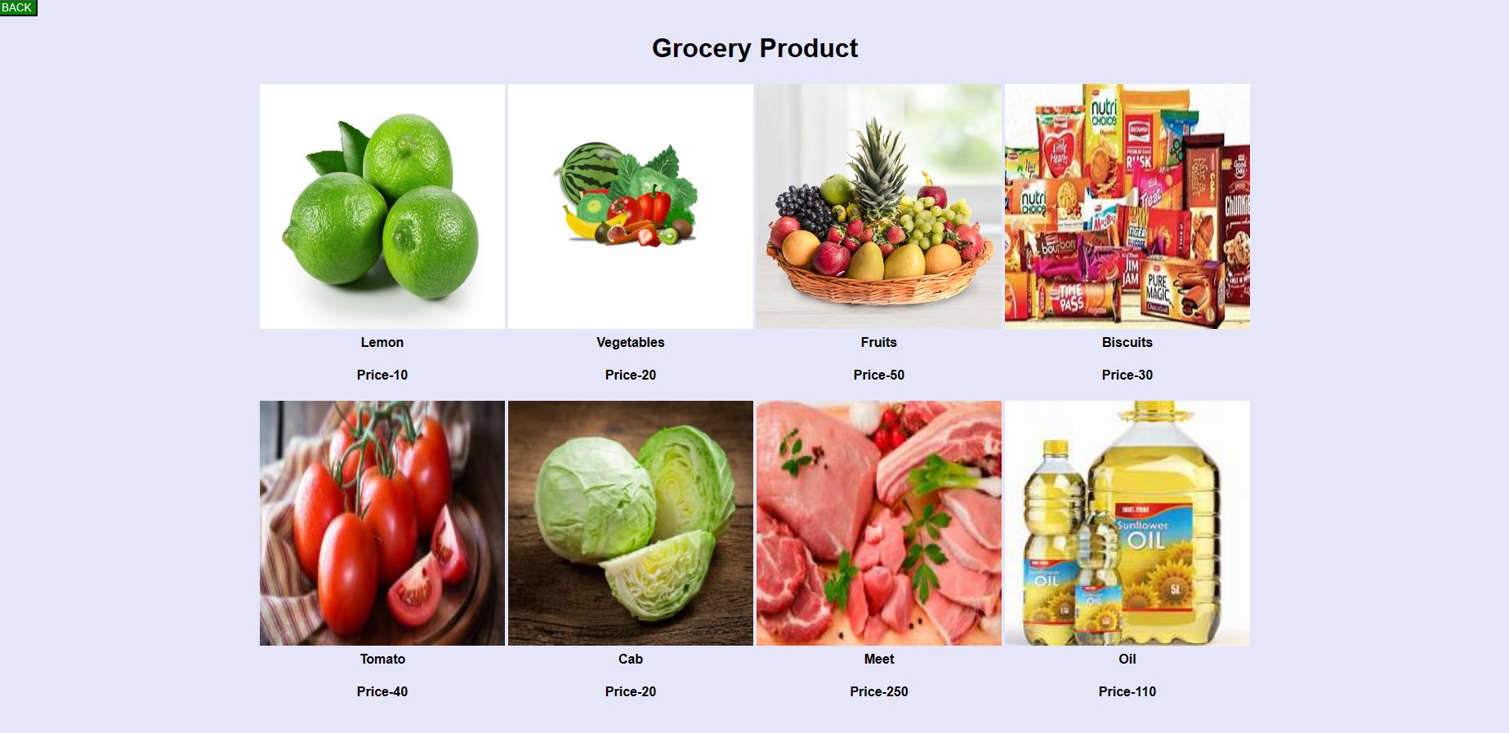

**Feedback page-**



**3. IMPLEMENTATION**

* **SYSTEM REQUIREMENTS-**
* **Hardware-**
* Any Compatible Computer.Processor : 7th Gen Intel R CoreTM i5-12400
* Installed RAM : 8.00 GB
* System Type – 32-bit operating system, *32-based processor.
* **Software-**

1] Any Windows OS.

2] Text Editor like Notepad.

* **Technologies Used-**

1] HTML, CSS and JavaScript (Front-end).

2] MySQL (Back-end).

* **Software used at (Front-end)-**
* **HTML-**
* HTML (Hyper Text Markup Language) is the most basic building block of the Web. It defines the meaning and structure of web content. Other technologies besides HTML are generally used to describe a web page’s appearance/presentation(CSS) or functionality/behavior (Javascript).
* “Hypertext” refers to links that connect web pages to one another, either within a single website or between websites. Links are a fundamental aspect of the web. By uploading content to the Internet and linking it to pages created by other people, you become an active participant in the World Wide Web.
* The Web is made out of three programming languages, HTML, CSS and Javascript. HTML stands for HyperText Markup Language. HTML marks up the content of a site. Basically it tells the user’s computer what things are. It also provides access to an incredible amount of functionality that’s already built directly into the browser.
* **CSS (Cascading Style-sheets)-**
* CSS stands for Cascading Style Sheets. CSS provides visual styling and layout for everything on the web page. It makes each web page look they way that it looks, colour, typography and size. And we can add simply animations and interaction through CSS.
* CSS is among the core language of the open web and is standardlized across Web browsers. Previously, the development of various parts of CSS specification was done synchronously, which allowed the versioning of the latest recommendations. You might have heard about CSS1, CSS2.1, or even CSS3. There will never be a CSS3 or a CSS4; rather, everything is now CSS without a version number.
* CSS has a bit more logic to it. There’s a bit more computer science structure there, which makes it a bit more fragile, and a bit more powerful. It does still have a tremendous amount of resilience. When something goes wrong in CSS, the browser will skip just that section of code and not apply that styling. But it will go on to apply the rest. It might not come out completely correct, the browser will do its best and most of it will work.
* **JAVASCRIPT-**
* JavaScript is a programming language that provides the ability to create a more powerful interactivity. The more complex and rich an interface becomes, the more likely that Javascript is used to make that experience seamless for the site’s users. This can be confusing or frustrating for some coders.
* JavaScript, it helps you developing great front-end as well as back-end software using different Javascript based frameworks like jQuery, Node.JS etc. JavaScript is everywhere, it comes installed on every modern web browser and so to learn JavaScript you really do not need any special environment setup. For example Chrome, Mozilla Firefox, Safari and every browser you know as of today, supports JavaScript.
* JavaScript is the most powerful. There are many things that JavaScript can do thar HTML and CSS cannot do. But it’s also the most fragile. If something’s wrong with the code, or the browser is too old to know what that code means, the browser will stop.

The web runs on Mac, Windows, iOS, Android, Linux, other mobile OS’s, Ebook readers, game consoles, televisions, watches. There’s a wide diversity of devices that run HTML, CSS and JavaScript in some form or fashion. That was the entire point of the web, the reason it was invented. To provide a way for pretty remarkable. This is made possible by havin three different kinds of programming languages, each doing part of the job.

* **Software used at (Back-end) –**
* **MySQL-**

MySQL is an open-source relational database management system. Its name is a combination of “My”, the name of co-founder Michael Widenius’s daughter My, and “SQL”, the acronym for Structured Query Language.

MySQL is a relational database management system based on the Structured Query Language, which is the popular language for accessing and managing the records in the database. MySQL is open-source and free software under the GNU license. It is supported by **Oracle Company.**

It is very important to understand the database before learning MySQL. A database is an application that stores the organized collection of records. It can be accessed and manage by the user very easily. It allows us to organize data into tables, rows, columns, and indexes to find the relevant information very quickly. Each database contains distinct API for performing database operations such as creating, managing, accessing, and searching the data it stores. Today, many databases available like MySQL, Sybase, Oracle, MongoDB, PostgreSQL, SQL Server, etc. In this section, we are going to focus on MySQL mainly.

**Reports**

Report Of Komal Satabale-

|  |  |
| --- | --- |
| Grocery Management |  |
| Customer Name: | Komal Pandurang Satabale |
| Product Name: | Orange |
| Price: | 50Rs. |
| Mobile No.: | 7666401618 |
| Payment Mode: | Cash |
| Address: | Rajarampuri, Kolhapur |

Report Of Ankita Patil-

|  |  |
| --- | --- |
| Grocery Management |  |
| Customer Name: | Ankita Nilesh Patil |
| Product Name: | Onion |
| Price: | 100Rs. |
| Mobile No.: | 8317201294 |
| Payment Mode: | Online |
| Address: | Balaji Park, Kolhapur |

Report Of Archana Patil-

|  |  |
| --- | --- |
| Grocery Management |  |
| Customer Name: | Archana Anandrao Patil |
| Product Name: | Meet |
| Price: | 250Rs. |
| Mobile No.: | 9158433241 |
| Payment Mode: | Online |
| Address: | Shahu Colony, Kolhapur |

Report Of Arpana Patil-

|  |  |
| --- | --- |
| Grocery Management |  |
| Customer Name: | Arpana Anandrao Patil |
| Product Name: | Tomato |
| Price: | 70Rs. |
| Mobile No.: | 8055279935 |
| Payment Mode: | Cash |
| Address: | RagaramPuri 11th line, Kolhapur |

**CONCLUSIONS AND SUGGESTIONS**

The first conclusion this study provides is the realization of online grocery shopping in Portugal as being a niche market. Although being generally well accepted throughout the world as a & Hooker, 2009; Hand, Riley, Harris, Singh & Rettie, 2009), during the execution of the methodology much difficulty was found in reaching actual online grocery shoppers, as the low survey response rate demonstrated. The latter could possibly be due to the general lack of interest of the targeted respondents on the study, the inappropriate method of survey distribution, or the actual low number of online grocery shoppers. Despite the publically announced high number of consumer registrations to the two main online grocery stores (Acepi,2011), which can be assumed as revealing consumers’ intentions to try out or search more information related to this type of purchase, no official numbers of actual purchases were found in the market and the estimate for Continente Online presented in this study (LINI, 2010;Dionisio, Pereira & Cardoso, 2012) was found to be far lower from the announced number of registered clients. Furthermore, from the sample that was possible of being collected, almost 60% of shoppers claim to shop online for groceries less than once a month. Moreover, all consumers from the sample collected declared shopping for groceries in other traditional stores and showed high levels of aversion towards the purchase of several product categories. Given these facts and the ad-hoc consumer information collected during the process of this study, it can be suggested that online grocery shopping in Portugal is still a developing market facing several market penetrating issues. Nonetheless, through the elaboration of this research, it was possible to gather information regarding the overall decision -making process of online grocery shoppers, which, as mentioned, has seldom been the focus of previous research. In general, results revealed high levels of similarities between consumers, which is congruent with a small 47 niche market. Moreover, regarding pre-decisional factors, and although results cannot be generalized, both studies uncovered similar results for the average shopper planning patterns, which further reinforces the previous point. As per the overall decision- making process, this was generally found to be rational process with utilitarian motivations, following defined planning and purchasing patterns established from previous shopping trips. Furthermore, the study of consumer shopping orientations framing online grocery shopping (e.g. Morganosky & Cude, 2000; Ramus & Nielsen, 2005; Verhoef & Langerak, 2001; POPAI,2011) – price-sensitivity and convenience. Consumer types within which, it was possible to analysis different decision making variables, according to the defined research questions, leading to the conclusion of the existence of different browsing and purchasing strategies. Two main strategies were found to exist, which vary essentially in the difference between the level of convenience and price-sensitivity orientations.

**ANNEXURE**

|  |
| --- |
| <html lang="en">  <head>  <title>Bootstrap Example</title>  <meta charset="utf-8">  <meta name="viewport" content="width=device-width, initial-scale=1">  <link rel="stylesheet" href="css/bootstrap.min.css">  <link rel="stylesheet" href="fontawesome/fontawesome-free-6.4.0-web/css/all.min.css">  <link rel="stylesheet" href="fontawesome/fontawesome-free-6.4.0-web/css/fontawesome.min.css">  </head>  <style>  .page1{  background-image: url("images/page1.jpg");  background-size: cover;  background-color:darkkhaki;  height: 500px;  width: 1300px;  padding: 250px 250px;  align-items: center;  justify-content: center;  }  .page1 h1{  color: azure;  }  .footer .credit{  text-align: center;  margin-top:2rem ;  padding:1rem ;  padding-top: 2.5rem;  font-size:2rem ;  color: black;  border-top: border;  }  .footer .credit span{  color:crimson;  }  .footer{  text-align: center;  }  </style>  <body>  <nav class="navbar navbar-expand-sm navbar-light">  <div class="container-fluid">  <div class="navbar-header">  <a class="navbar-brand" href="#">  <i class="fa-sharp fa-solid fa-basket-shopping" style="color:orangered"></i>    <h3>Groco</h3></a>  </div>  <ul class="navbar-nav mx-auto">    <li class="nav-item"><a href="Arpana Code.html" class="nav-link">Home</a></li>    <li class="nav-item"><a href="features.html" class="nav-link">Features</a></li>  <li class="nav-item"><a href="product.html" class="nav-link">Products</a></li>  <li class="nav-item"><a href="categories.html" class="nav-link">Categories</a></li>  <li class="nav-item"><a href="review.html" class="nav-link">Review </a></li>  <li class="nav-item"><a href="blogs.html" class="nav-link">Blogs</a></li>  <li class="nav-item"><a href="contact.html" class="nav-link">Contact Us</a></li>  <li class="nav-item"><a href="gallery.html" class="nav-link">Gallery_Page</a></li>  <li class="nav-item"><a href="feedbackform.html" class="nav-link">Feedback_Page</a></li>  </ul>    </div>  </nav>  <!-- ------------------------caption-------------------------------------------------------- -->  <div class="container-fluid page1">  <div class="cap"><h1><marquee behavior="scroll" direction="up" scrollamount="2" height="70px">  Fresh And Organic Products For You</marquee></h1></div>  </div>  <!------------------------Contact-------------------------------------------------------->  <section class="footer">  <div class="box-container">  <div class="box">  <h1><p>Groco</p>  </h1>  <div class="share">  <a href="https://www.facebook.com/" class="fa-brands fa-facebook"></a>  <a href="https://twitter.com/?lang=en-in" class="fa-brands fa-square-twitter"></a>  <a href="https://www.instagram.com/?hl=en" class="fa-brands fa-instagram"></a>  <a href="https://www.linkedin.com/login" class="fa-brands fa-linkedin"></a>  </div>  </div>    <div class="box">  <h3>Contact info</h3>  <a href="#" class="links"><i class="fa-solid fa-phone"></i>+123-456-7890</a><br>  <a href="#" class="links"><i class="fa-solid fa-phone"></i>+111-222-333</a><br>  <a href="#" class="links"><i class="fa-solid fa-envelope"></i>patilk@gmail.com</a><br>  <a href="#" class="links"><i class="fa-solid fa-location-dot"></i>mumbai,india</a><br>    </div>    <div class="box">  <h3>Quick link</h3>  <a href="#" class="">Home</a><br>  <a href="#" class="">Features</a><br>  <a href="#" class="">Products</a><br>  <a href="#" class="">Categories</a><br>  <a href="#" class="">Review</a><br>  <a href="#" class="">Blogs</a><br>    </div>    <div class="box">  <h3>News letter</h3>  <p>Subscribe for latest updates</p>  <input type="email" placeholder="your email" class="email">  <input type="submit" value="Subscribe" class="btn">    <div class="credit">Created By <span>AP designer</span>| All Rights Reserved</div>    </section>  <script src="js/jquery-3.3.1.js"></script>  <script src="js/bootstrap.min.js"></script>  </script>  </body>  </html> |

Kamala College, Kolhapur

**Student Guide Meet Record**

2023-2024

|  |  |  |
| --- | --- | --- |
| **Title of Project** | **Grocery Shopping** | **Class:**  BCA-II  (Sem-IV) |
| **Student Name** | Arpana Anandrao Patil | **Guide Name:**  Smt. Rutuja Bhedate |

|  |  |  |  |  |  |
| --- | --- | --- | --- | --- | --- |
| **Sr.** | **Date** | **Description** | **Signature of Guide** | **Signature of Student** | **Guide Remark** |
| 1 |  | Problem Identification and Topic and Title finalization  (1st week of semester) |  |  |  |
| 2 |  | SRS submission and approval (6th week of semester) |  |  |  |
| 3 |  | Logical Design of system (DFD, System flowchart, ERD, UML diagram, Decision tables, Decision trees, site map which is applicable)  (7th week of semester) |  |  |  |
| 4 |  | Database Design (8th week of semester) |  |  |  |
| 5 |  | I/O Design (with reports) (10th week of semester) |  |  |  |
| 6 |  | Submission of Draft Project Report (11th week of semester) |  |  |  |
| 7 |  | Submission of Final Project Report (12th week of semester) |  |  |  |
|  |  |  |  |  |  |

HOD/Director/Principle

**REFERENCES**

[1] JavaScript Enlightenment, Cody Lindley-First Edition, based on JavaScript 1.5, ECMA-262, Edition

[2] Mc GrawHill’s , Java : The complete reference 7th Edition, Herbert Schildit

[3] Complete CSS Guide, Maxine Sherrin and John Allsopp-O’ReillyMedia; September 2012

[4] <http://www.w3schools.com/htm;/defualt.asp,http://www.w3schools.com/css/default.asp,http://>

www.w3schools.com/js/default.as